SMCRMATH Editorial Board
Editor-in-Chief
Prof. José Francisco Gómez Aguilar
Designation & Affiliation: Professor, Department of Electronic Engineering, National Center for Research and Technological Development (CENIDET), Cuernavaca, Morelos, Mexico.
Details- He is a CONACyT Chair Professor–Researcher commissioned to the Department of Electronic Engineering at CENIDET. He is a member of the State System of Researchers of the State of Morelos and a National Researcher Level I in the Mexican National System of Researchers (SNI). He is also an accredited evaluator in the CONACyT Registry of Evaluators (RCEA) in the area of Engineering and Industry. He completed a postdoctoral fellowship (2013–2014) in the Solar Materials Department at the Institute of Renewable Energies (IER), UNAM.
He has introduced fractional mathematical operators bearing his surnames, including the Atangana–Gómez fractional derivative with three orders and the Atangana–Aguilar fractional derivative with two orders, formulated in both Liouville–Caputo and Riemann–Liouville senses, with applications published in high-impact international journals.
Research Area: Fractional calculus and nonlocal operators; mathematical modeling of complex and anomalous transport phenomena; nonlinear dynamics and chaos; differential equations of integer and fractional order; applied Mathematics, and applied physics.
Institutional Profile: https://www.cenidet.edu.mx/archivos/cv/electronica/Jose%20Francisco%20Gomez%20Aguilar.pdf
Institutional Email: jose.ga@cenidet.tecnm.mx
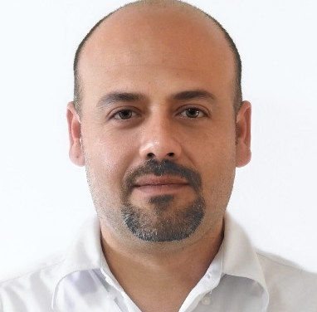

Dr. Sachin Kumar
Designation & Affiliation: Assistant Professor, Department of Mathematics, Government Degree College, Budaun, Uttar Pradesh, India
Details- Dr. Sachin Kumar is a distinguished academician and researcher in the field of Bio-Mathematics, currently serving as an Assistant Professor at Government Degree College, Budaun. With a strong research background, he has published 29 SCI-indexed papers in reputed international journals, making significant contributions to mathematical sciences. His research has been widely recognized, with more than 595 citations, an h-index of 16 and an i10-index of 22, reflecting the depth and impact of his scholarly work.
Research Area: Biomathematics, Mathematical Biology, Epidemiological Modelling, Neural Network
Institutional Profile: https://gdcbudaun.org/wp-content/uploads/2022/04/Dr-Sachin-Kumar.pdf
Institutional Email: drsachinkumar@gdcbudaun.org
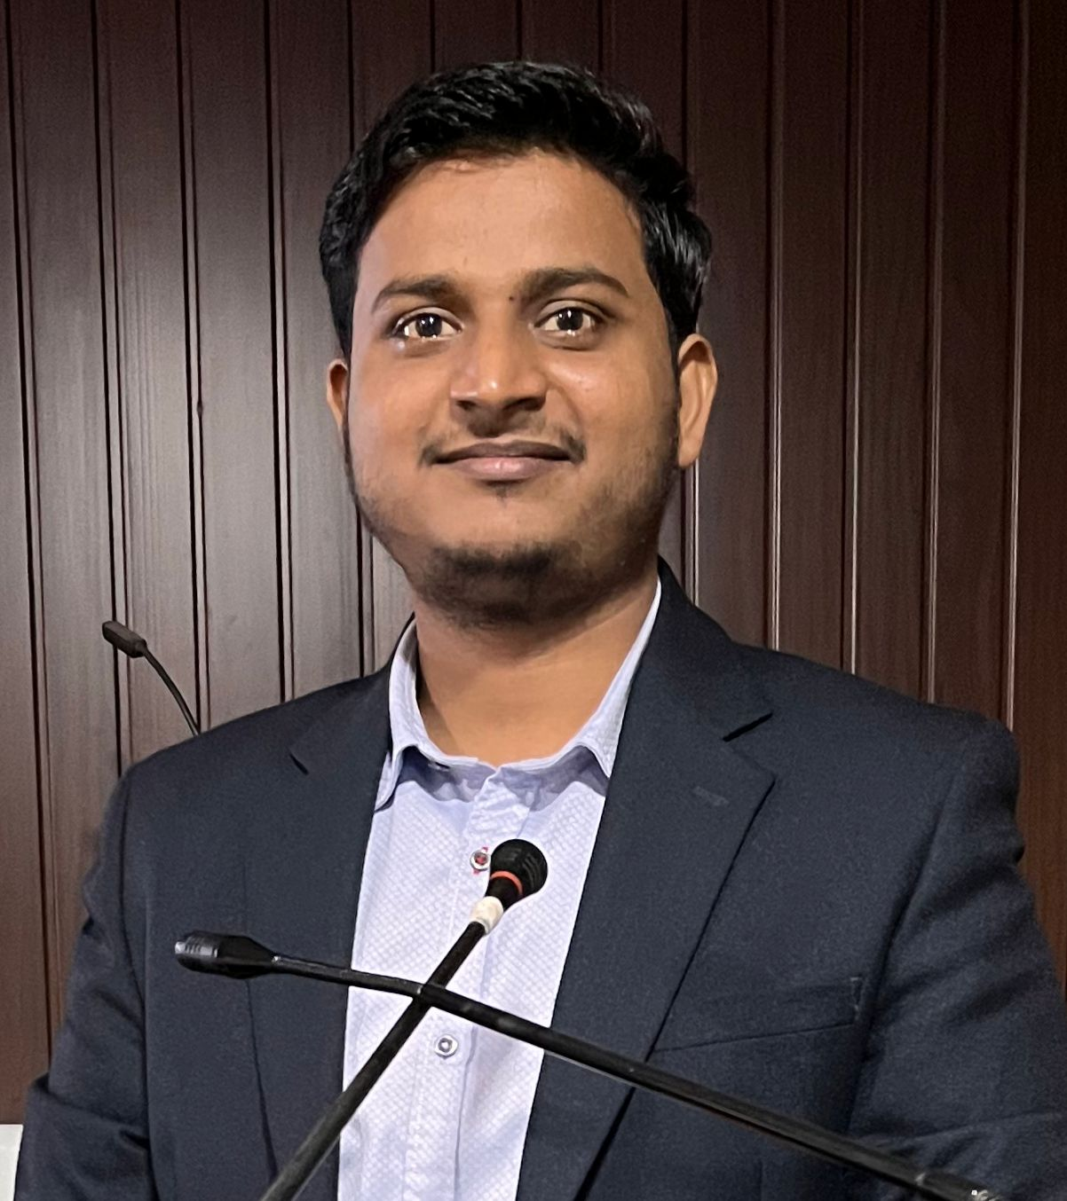
Dr. Prashant Pandey
Designation & Affiliation: Assistant Professor, Department of Mathematics, K.S. Saket P.G. College Ayodhya, Uttar Pradesh, India.
Details- Dr. Prashant Pandey, Ph.D., IIT (BHU), Varanasi, is a dedicated mathematician and researcher, recognized as an Honorary Professor by Cypress University, Texas, USA. His academic work spans fractional calculus, mathematical modelling, porous media, and machine learning, where he has contributed to advancing both theoretical understanding and practical applications. With a commitment to fostering analytical thinking and research culture among students, Dr. Pandey actively engages in mentoring, academic collaborations, and scholarly initiatives, enriching the activities of the Mathematics Society through workshops, lectures, and outreach programs.
Research Area: Biomathematics, Mathematical Biology, Epidemiological Modelling, Neural Network
Institutional Profile: https://kssaketpgcollege.ac.in/wp-content/uploads/2023/08/shortcv.pdf
Institutional Email: drprashantpandey@kssaketpgcollege.ac.in
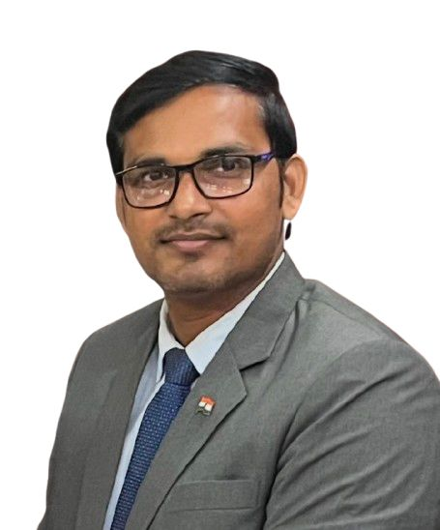
Editors
Prof. Dumitru Baleanu
Designation & Affiliation: Professor, Department of Mathematics, Lebanese American University, Beirut, Lebanon.
Details- Dr. Dumitru Baleanu is a professor of mathematics in the Computer Science and Mathematics Department. Dr. Baleanu is a pioneer of the fractional variational principles and their applications in control theory. Besides, he is one of the co-authors of the seminal paper entitled “Anomalous diffusion expressed through fractional order differential operators in the Bloch-Torrey equation”, published by the Journal of Magnetic Resonance in 2008, which plays a fundamental role in diffusion-weighted MRI. Dr. Baleanu is a co-author of more than 25 books published by Springer, Elsevier and World Scientific. His H index is 99. He is also a fellow of the African Academy of Sciences. Dr. Baleanu has supervised to successful completion of three PhD and 13 Master’s students at the University of Guelma, Algeria, University of Mazandaran, Iran and Çankaya University, Turkey.
Research Area: fractional differential equations and their applications, discrete mathematics, image processing, mathematical biology, mathematical physics, soliton theory, Lie symmetry, dynamic systems on time scales, computational complexity, the wavelet method and its applications
Institutional Profile: https://soas.lau.edu.lb/about/people/dumitru-baleanu.php
Institutional Email: dumitru.baleanu@gmail.com
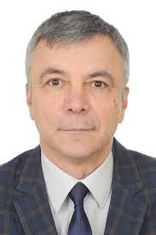
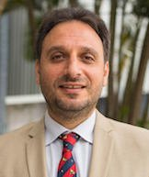
Prof. Gennaro Infante
Designation & Affiliation: Professor of Mathematical Analysis, University of Calabria, Italy
Details- Prof. Gennaro Infante is a Full Professor in the Department of Mathematics and Computer Science at the University of Calabria (Italy). He previously served as Postdoctoral Researcher, Assistant Professor, and Associate Professor, obtaining the Italian National Scientific Habilitation as Full Professor in 2018 and assuming the position in October 2024. He has extensive editorial experience with leading journals in differential equations and nonlinear analysis, is an active member of major mathematical societies, and regularly contributes to the organization of international conferences, workshops, and Ph.D. training activities, including service on the Scientific Committee of C.I.M.E.
Research Area: Differential Equations and Nonlinear Functional Analysis, with particular emphasis on boundary value problems for ordinary and partial differential equations, fixed point index theory and its applications, and nonlinear eigenvalue problems.
Institutional Profile: https://sites.google.com/unical.it/gennaroinfante
Institutional Email: gennaro.infante[at]unical.it

Dr. Vijay Kumar Yadav
Designation & Affiliation: Assistant Professor, Department of Mathematics, Amity School of Applied Sciences, Amity University, Haryana, India.
Details- Dr. Vijay Kumar Yadav is an Assistant Professor of Mathematics at Amity University Haryana, India, and his research focuses on nonlinear dynamical systems, chaos theory, synchronization, fractional calculus, and neural networks. He received his Ph.D. in Mathematics from the Indian Institute of Technology (BHU), Varanasi, where his doctoral work focused on chaos and synchronization phenomena in dynamical systems. He has over six years of teaching experience and three years of postdoctoral research experience and has authored more than 45 research publications in reputed international journals. He has presented his research at several prestigious international conferences, including ICIAM (Spain), BMC-BAMC (UK), and IEEE conferences in Europe. Dr. Yadav is actively involved in mentoring young researchers and currently supervises Ph.D. and M.Sc. students in the areas of applied mathematics and dynamical systems. He also serves as a Guest Associate Editor for the journal Frontiers in Applied Mathematics and Statistics.
Research Area: complex behaviour in dynamical and neural network systems, with applications in engineering, cryptography, and artificial intelligence.
Institutional Profile: https://www.amity.edu/gurugram/aset/faculty_details.aspx?mpgid=927&pgidtrail=927&facultyid=3815
Institutional Email: vkyadav1@ggn.amity.edu
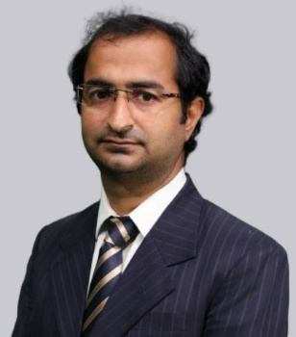

Dr. Shubham Jaiswal
Designation & Affiliation: : Assistant Professor, Department of Mathematics, PGDAV College, University of Delhi, Delhi, India
Details- Dr. Shubham Jaiswal, Assistant Professor of Mathematics at PGDAV College, University of Delhi, holds a Ph.D. from IIT (BHU), Varanasi (2018), with research expertise in fractional calculus, porous media transport, numerical methods, and reaction–diffusion systems. He has served in reputed institutions such as South Asian University, J.C. Bose University of Science & Technology, and Akal University, and has over a decade of combined teaching and research experience. His scholarly contributions include numerous research papers published in Springer, Elsevier, Begell House, and other international journals. He has presented his work at national and international conferences including ICMMS, ICMC, ISFT, and NCETPFS, and delivered invited talks on fractional models, numerical schemes, and porous media flow. Dr. Jaiswal has also taken up multiple academic responsibilities, including session chair, event coordinator, MOOC co-coordinator, department website coordinator, and NAAC committee member, contributing significantly to academic development, curriculum strengthening, and institutional activities.
Research Area: complex behaviour in dynamical and neural network systems, with applications in engineering, cryptography, and artificial intelligence.
Institutional Profile: https://www.pgdavcollege.in/academics/departments/faculty/faculty-detail/324/#
Institutional Email: shubham.jaiswal@pgdav.du.ac.in
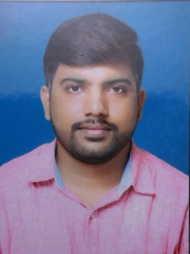

Dr. Kushal Dhar Dwivedi
Designation & Affiliation: Assistant Professor (Grade-II), Department of Sciences, IIITDM, Kurnool, Andhra Pradesh
Details- Dr. Kushal Dhar Dwivedi holds a Ph.D. in Fractional Differential Equations and Numerical Analysis from the Indian Institute of Technology (BHU), Varanasi, India. His research interests focus on fractional differential equations and numerical methods. He is currently serving as Assistant Professor (Grade II) in the Department of Sciences at IIITDM Kurnool since December 11, 2022, and previously worked as Assistant Professor at Shri Neelkantheswar Government Postgraduate College, Madhya Pradesh, from December 2019 to December 2023. He qualified CSIR–JRF/NET with All India Rank 48 in June 2016 and achieved a GATE score of 413 with All India Rank 318 in March 2016. He has published extensively in reputed international journals such as Journal of Computational and Nonlinear Dynamics (ASME), European Physical Journal Plus, Numerical Methods for Partial Differential Equations, Neural Processing Letters, Mathematics and Computers in Simulation, and Mathematical Methods in the Applied Sciences, with research centered on numerical solutions of fractional-order differential equations. He has presented his work at international conferences and has taught undergraduate and postgraduate courses including Calculus, Real Analysis, Differential Equations, Complex Analysis, and Functional Analysis.
Research Area: Neural Network, Fractional Differential Equation,
Institutional Profile: https://iiitk.ac.in/Dr.-Kushal-Dhar-Dwivedi/page
Institutional Email: kddwivedi@iiitk.ac.in


